Module 5.2 Assignment

CHAR_LENGTH will return the number of characters in a string. This may be used to determine how long a word or entry is. This might be useful in a function that helps with something like scrabble or words with friends.
Alias “Word Length”
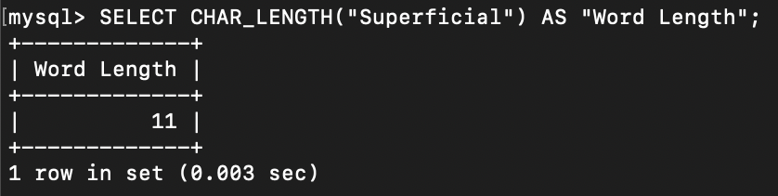

CONCAT adds to strings, or performs concatenation of strings…. This one is for my kids who are in LOVE with “monkey math,” which is the concatenation of numbers.
Alias “Monkey Math!”
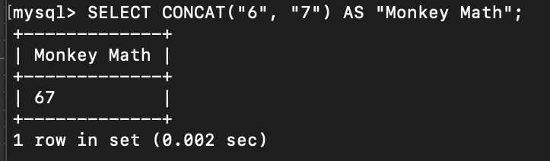

DAYOFYEAR gives the number (from 1-366) of the day of the year it is. This is commonly known as the Julian date. At work, we use something called a batch date to mark the date for many things (most notably the day an order comes into the warehouse for something to be shipped out to a store). The batch date has other information in it, but ends with the year followed by the Julian date (so #######2025315). At work, we would use this for the batch date. For added fun, I used the CURDATE() function to get the current date (11-11-2025).
Alias “Batch Date”
